Place these events in chronological order:
- Beginning of the Siege of Leningrad - 10
- Allies take Sicily -9
- Beginning of the Battle of Britain - 4
- Battle of El Alamein - 8
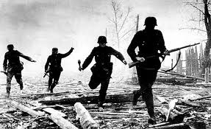
- Hitler attacks Denmark and Norway - 2
- Lend-Lease Act - 6
- Hitler invades Poland - 1
- Hitler attacks the Soviet Union - 5
- Japan attacks Pearl Harbor - 7
- Paris falls to the Nazis - 3
- D-Day - 11

