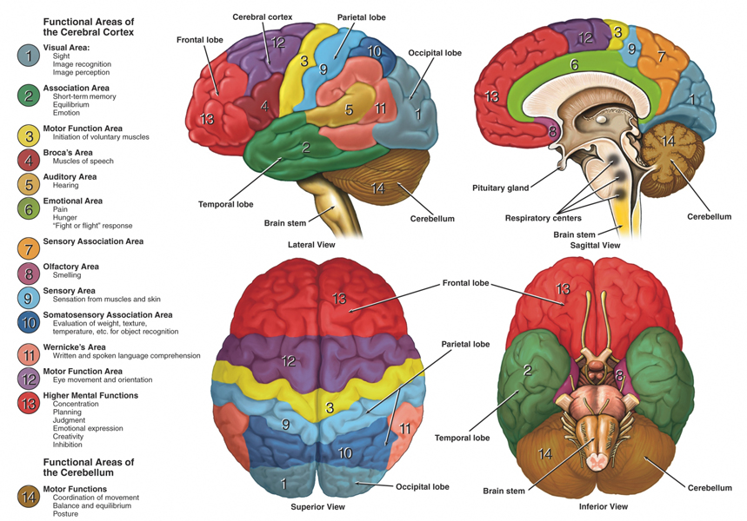

- What areas of the brain controls motor functioning?
- What area of the brain controls emotional outbursts and creativity?
- What area of the brain controls senses?
- What are of the brain controls respiration?
- Speech and hearing can be found about where in the brain?

