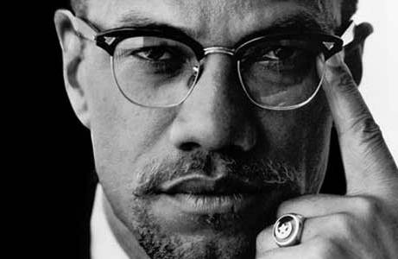
Civil Rights: Study Guide
Identify the following people and organizations:
- Linda Brown
- Elizabeth Eckford 10. SNCC
- Ernest Green 11. “Bull” Connor
- Orval Faubus 12. James Merideth
- Dwight D. Eisenhower 13. George Wallace
- John F. Kennedy 14. John Lewis
- Dr. Martin Luther King, Jr. 15. Goodman/Cheney/Schwerner
- Rosa Parks 16. Malcohm X
- Medger Evers 17. SCLC
Answer the following questions as thoroughly as possible. The more complete your answer, the better you can review for the test.
- What did Plessey v. Ferguson set up in the South?
- Why was the Brown v. Board of Education case so important for the Civil Rights Movement?
- Why was it important for the Little Rock 9 to get into Central High school?
- What did the Black community in Montgomery, AL do when Rosa Parks was arrested? Was this response successful? Why or why not?
- How did SNCC integrate lunch counters across the South?
- Who were the freedom riders and what were they trying to accomplish?
- What did the experience in Albany, GA teach Civil Rights leaders?
- Summarize what went on during the protest in Birmingham, AL.
- Why did 200,000 people march on Washington, D.C. in the summer of 1963?
- Why didn’t the Civil Rights Act of 1964 give blacks equality?
- Why did the leaders of the Civil Rights movement change their focus to voting?
- Why was getting blacks to register to vote so difficult in the South?
- What was the goal behind the “Freedom Summer” campaign?
- How did Andrew Goodman, James Chaney, and Michael Schwerner impact the Civil Rights Movement?
- What happened to marchers in Selma in 1965? How did this impact the movement?
- What did the Voting Rights Act of 1965 do? Was the act successful? What statistics can you use to show its effectiveness?
- How did the Black Power Movement differ from the approach taken by Dr. King and other civil rights leaders?
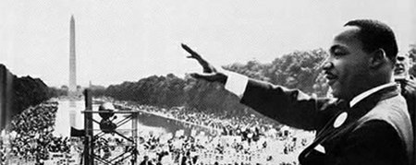
- Explain why the movement needed television and other media in order to achieve equality.

